Obtaining service information: Step-by-step exercises
In this exercise, you will explore the use of the Get-Service cmdlet as you retrieve service information from your computer. You will sort and filter the output from the Get-Service cmdlet. In the second exercise, you will use WMI to retrieve similar information. You should compare the two techniques for ease of use and completeness of data.
Obtaining Windows service information by using the Get-Service cmdlet
1. Start the Windows PowerShell console.
2. From the Windows PowerShell prompt, use the Get-Service cmdlet to obtain a listing of all the services and their associated status. This is shown here.
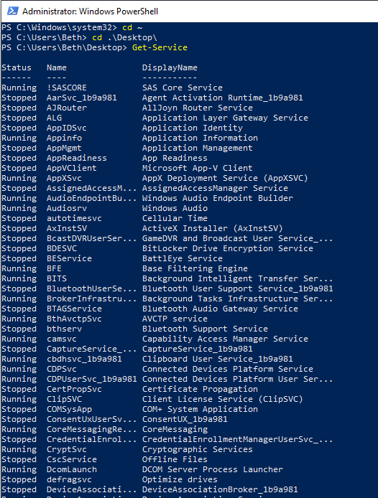
Insert command and screen shot of results

3. Use the Sort-Object cmdlet to sort the listing of services. Specify the status property for Sort-Object. To sort the data based upon status, pipeline the results of the Get-Service cmdlet into the Sort-Object cmdlet. Use the sort alias for the Sort-Object cmdlet to reduce the amount of typing. The results are shown here.
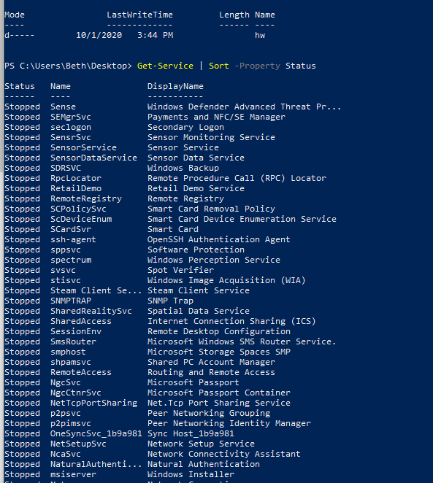
Insert command and screen shot of results
4. Use the Get-Service cmdlet to produce a listing of services. Sort the resulting list of services alphabetically by name. To do this, use the Sort-Object cmdlet to sort the listing of services by the name property. Pipeline the object returned by the Get-Service cmdlet into the Sort-Object cmdlet. The command to do this, using the sort alias for Sort-Object, is shown here.
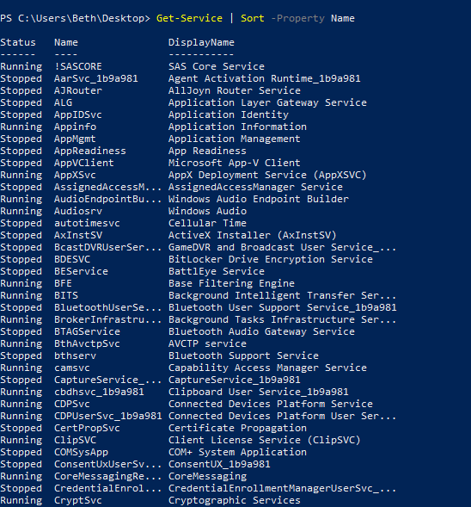
Insert command and screen shot of results
5. Use the Get-Service cmdlet to produce a listing of services. Sort the objects returned by both the name and the status of the service. The command to do this is shown here.
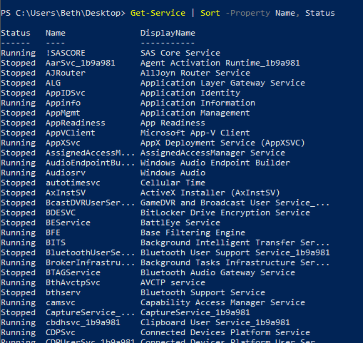
Insert command and screen shot of results
6. Use the Get-Service cmdlet to return objects containing service information, using the DisplayName parameter and specifying *server* to retrieve all service objects that contain the word server in the display name.
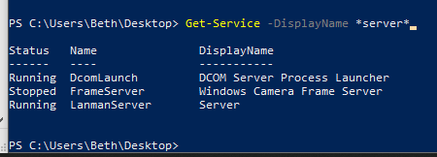
Insert command and screen shot of results

7. Use the Get-Service cmdlet with the Name parameter to retrieve an object that represents the BITS service. The code that does this is shown here.
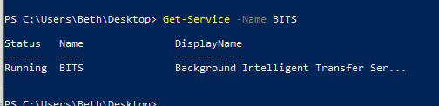
Insert command and screen shot of results
8. Press the Up Arrow key to retrieve the previous command that retrieves the BITS service. Store the resulting object in a variable called $a. This code is shown here.
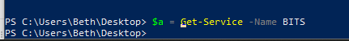
Insert command and screen shot of results
9. Pipeline the object contained in the $a variable into the Get-Member cmdlet. You can use the gm alias to simplify typing. This code is shown here.
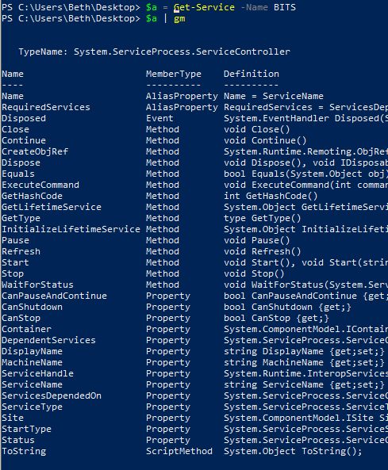
Insert command and screen shot of results
10. By using the object contained in the $a variable, obtain the status of the Bits service. The code that does this is shown here.
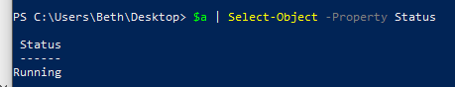
Insert command and screen shot of results
11. If the Bits service is running, stop it. To do so, use the Stop-Service cmdlet. Instead of pipelining the object in the $a variable, you use the -InputObject argument from the Stop-Service cmdlet. The code to do this is shown here.
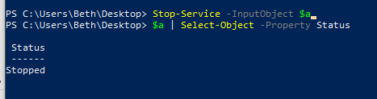
Insert command and screen shot of results
12. If the Bits service stops, use the Start-Service cmdlet instead of the Stop-Service cmdlet. Use the -inputobject argument to supply the object contained in the $a variable to the cmdlet. This is shown here.
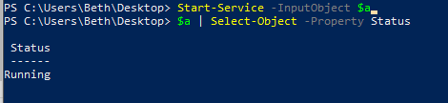
Insert command and screen shot of results
13. Query the status property of the object contained in the $a variable to confirm that the Bits service’s status has changed. This is shown here.
See above
Insert command and screen shot of results

This concludes this step-by-step exercise.

Note
If you are working with a service that has its startup type set to Disabled, Windows PowerShell will not be able to start it and will return an error. If you do not have administrator rights, Windows PowerShell will be unable to stop the service.

